Rise Park Academy Trust

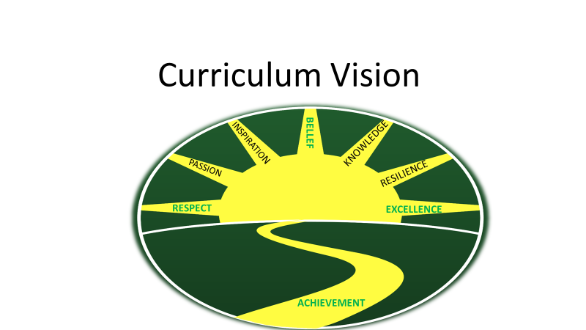

Remote Learning Policy

For: Academy Trust

Date of Issue: September 2020
Date of Review: September 2021
Responsible Staff: Laura Carter and Karen Palmer
Status: Approved by SLT/Staff
- Policy Scope:
This remote learning policy for staff aims to:
- Ensure consistency in the approach to remote learning for pupils who are not in school
- Set out expectations for all members of the school community with regards to remote learning
- Provide appropriate guidelines for data protection

- Roles and Responsibilities:
2.1 Teachers
When providing remote learning, teachers must be available between 8:30am and 3:30pm.
If teachers are unable to work for any reason during this time, for example due to sickness or caring for a dependent, they should report this using the normal absence procedure. This is to contact the Heads of School on 7am on the first day of absence, via a phone call.
When providing remote learning, teachers are responsible for:
Setting work for their class and for their year group if agreed. Work should be provided maths, literacy and a foundation subject daily. All work set should be differentiated and should be consistent across the year group. This work needs to be loaded on to the Class Dojo/Purple Mash/Mathletics platform at the beginning of the week, before 8:30am on a Monday. Pupils with limited access to devices should complete work online where possible, or be provided with work packs.
Providing feedback on work. All completed work on Class Dojo/Purple Mash/Mathletics platforms should be acknowledged daily when submitted. Detailed written feedback that is actionable should be given on literacy and maths work; a minimum of two comments per subject per week. Foundation subject work should be commented on at least once a week. Feedback can be given via the like buttons on the learning platforms and via the comment box. Please use Standard English, which is grammatically correct and not text type/abbreviations to comment on work.
Keeping in touch with pupils who are not in school and their parents. Daily contact should be made with pupils on the class dojo platform, via feedback, blog posts on the class story and via the messaging system. Where pupils do not have access to devices, a weekly call should be made to this pupil to check in with how they are getting on with the work packs provided.
Teachers should answer emails from parents/carers within working hours (Mon-Fri 8:30am-3:30pm).
Safeguarding concerns should be reported to the DSL’s immediately
via telephone call, and an emailed disclosure form. Any complaints, or concerns shared by parents and pupils please refer to the parent/carer to a member of the SLT team, and contact the SLT team to make them aware of this.
Pupils who do not complete home learning should be positively encouraged regularly via phone calls, messages from the teacher. Class Dojo points, and virtual certificates to be handed out when pupils have completed work at home as a reward.
Attending virtual meetings with staff, parents and pupils. During virtual meetings, teachers should dress appropriately. Please avoid areas with background noise, and ensure that there is nothing inappropriate in the background. Use a headset, earphones where possible.

Teachers will be expected to provide home learning to children isolating because of COVID-19, or shielding based on medical advice. Where there is a crossover, of some teachers working in school and some working from home. All teachers will still be responsible for providing learning in school and remote learning. Year group leaders should use their discretion to distribute tasks to their year group colleagues to ensure all areas are covered.
2.2 Support Staff
When assisting with remote learning, teaching assistants must be available between 8:30am and 3:15pm
If support staff are unable to work for any reason during this time, for example due to sickness or caring for a dependent, they should report this using the normal absence procedure. This is to contact the Heads of School on 7am on the first day of absence, via a phone call.
Support Staff will be required to assist with remote teaching and learning, as directed by the Year Group Leader. This could include:
- Creating resources, such as worksheets
- Researching and finding suitable online materials for pupils to use
- Preparation of work packs for children who are not able to access the online learning
- Providing direct support to identified children, where necessary, via telephone or video conferencing.
Support staff will also be required to attend virtual meetings with staff, parents and pupils where required. During virtual meetings, support staff should dress appropriately. Please avoid areas with background noise, and ensure that there is nothing inappropriate in the background. Use a headset, earphones where possible.
2.3 Subject Leaders
Alongside their teaching responsibilities, subject leads are responsible for:
Researching, considering and informing teaching staff on whether any aspects of the subject curriculum need to change to accommodate remote learning.
Working with teachers teaching their subject remotely to make sure all work set is appropriate and consistent.
Working with other subject leads and senior leaders to make sure work set remotely across all subjects is appropriate and consistent, and deadlines are being set an appropriate distance away from each other.
Monitoring the remote work set by teachers in their subject through regular conversations with teachers, or by reviewing work set on the home learning planning.
Alerting teachers to resources they can use to teach their subject remotely.
2.4 Senior leaders
Alongside any teaching responsibilities, senior leaders are responsible for:
Co-ordinating the remote learning approach across the school in liaison with Dr. Andrew Croft who is the remote learning subject leader.
Monitoring the effectiveness of remote learning. Through regular meetings with teachers and subject leaders, reviewing work set on the weekly home learning timetables, monitoring of how Class Dojo and other online platforms are being used effectively for learning, or reaching out for feedback from pupils and parents.
Monitoring the security of remote learning systems, including data protection and safeguarding considerations.
2.5 Designated safeguarding lead
The DSL is responsible for:
- Obtaining information from staff, supply staff, volunteers, children or parents and carers who have child protection concerns and to record this information. The Safeguarding team will be supported by each school’s Emotional Literacy Support Assistant.

- Following and implementing Rise Park Academy Trust’s Safeguarding and Child Protection Policies (RPJ and RPI- September 2020)
2.6 Pupils and parents
Staff can expect pupils learning remotely to:
- Be contactable during the school day via an electronic device such as an IPad or computer, or via the telephone.
- Complete work to the deadline set by teachers.
- Seek help if they need it, from teachers or support staff.
- Alert teachers if they are not able to complete work.
Staff can expect parents with children learning remotely to:
- Make the school aware if their child is sick or otherwise cannot complete work.
- Seek help from the school if they need it.
- Be respectful when making any complaints or concerns known to staff.
2.8 Directors
The directors are responsible for:
- Monitoring the school’s approach to providing remote learning to ensure education remains as high quality as possible.
- Ensuring that staff are certain that remote learning systems are appropriately secure, for both data protection and safeguarding reasons.

3. Who to contact
If staff have any questions or concerns about remote learning, they should contact the following individuals:
- Issues in setting work – talk to the relevant subject lead or SENCO
- Issues with behaviour – talk to year group leader
- Issues with IT – talk to IT staff, use IT log
- Issues with their own workload or wellbeing – talk to Heads of School
- Concerns about data protection – talk to School Business Manager, Steve Adams, or Executive Headteacher, Carolyn Fox.
- Concerns about safeguarding – talk to the DSL’s for the Academy Trust, Laura Carter and Rebecca McClean, or talk to a member of the safeguarding team if DSL’s unavailable for any reason, Karen Palmer and Lucy Nortje.

4. Data protection
4.1 Accessing personal data
When accessing personal data for remote learning purposes, all staff members will:
- Access the data, via Fronter or LGFL secure email service.
- Use devices such as laptops provided by school, or personal devices as agreed by the school e.g. if a phone is used to access Class DOJO app ensure that no personal data is screenshot or saved to phone or personal cloud.
4.2 Processing personal data
Staff members may need to collect and/or share personal data such as email addresses, phone numbers as part of the remote learning system. As long as this processing is necessary for the school’s official functions, individuals will not need to give permission for this to happen.
However, staff are reminded to collect and/or share as little personal data as possible online.
4.3 Keeping devices secure
All staff members will take appropriate steps to ensure their devices remain secure. This includes, but is not limited to:
- Keeping the device password-protected – strong passwords are at least 8 characters, with a combination of upper and lower-case letters, numbers and special characters (e.g. asterisk or currency symbol).
- Ensuring the hard drive is encrypted – this means if the device is lost or stolen, no one can access the files stored on the hard drive by attaching it to a new device.
- Making sure the device locks if left inactive for a period of time.
- Not sharing the device among family or friends.
- Installing antivirus and anti-spyware software.
- Keeping operating systems up to date – always install the latest updates.

5. Safeguarding
Please see RPI and RPJ Safeguarding and Child protection policies.

6. Monitoring arrangements
The Heads of School will review this policy annually.

7. Links with other policies
This policy is linked to our:
- Behaviour policy
- Safeguarding and child protection policy
- Data protection policy and privacy notices
- ICT and Internet acceptable use policy
- Online safety policy
- Peer-on- Peer Abuse Policy

