15th March 2021

Dear Parents/Carers,

SCHOOL POLLING STATION CLOSURE
THURSDAY 6TH MAY 2021

Rise Park Academy Trust Sunbeams Nursery, Infant and Junior schools will be used as a Polling Station on Thursday 6TH MAY 2021; therefore the whole school site will be CLOSED on this date.

Yours faithfully,

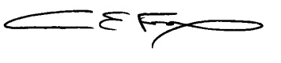

Mrs C Fox
Executive Headteacher

